- FOR IMMEDIATE RELEASE
Press Contact:
Junior League of Elizabeth-Plainfield, Nydia M Diefenbach
T: (908) 709-1177 / E: information@jlepnj.org

Junior League of Elizabeth-Plainfield Provides New Backpacks and School Supplies to local community partner Emmanuel Cancer Foundation
CRANFORD, NEW JERSEY {insert date here} – The Junior League of Elizabeth-Plainfield (JLEP) is excited to announce that through their partnership with local community partner Emmanuel Cancer Foundation (ECF), JLEP was able to provide new backpacks and school supplies to more than 20 ECF recipients.
JLEP’s Back to School Drive has been in operation for the last three years and this year was spearheaded by Helping Hands Community Service Projects Committee Chair, Jen McComb. Through Jen’s efforts, the League rallied together to provide either completed backpacks or various new school supplies to make a completed backpack. Plus JLEP received a generous donation of new backpacks from another local community partner Bijoux International Inc. that allowed them to focus on the school supplies needed and double their donation efforts from the previous year.
For almost 95 years, JLEP has been helping women and children in need in the greater Union County area. From the League’s signature projects Career Closet and Teen Closet to the League’s annual Angel Tree partnership with Healthy Families Elizabeth, JLEP is proud of the volunteer work it accomplishes and the positive impact provided to the local community. JLEP is a small but mighty league that loves the work they do!
JLEP operates from September through May during the League’s calendar year. To learn more about JLEP, please go to www.jlepnj.org or email information@jlepnj.org.
ABOUT the Junior League of Elizabeth-Plainfield
The Junior League of Elizabeth-Plainfield is a chapter of the Association of Junior Leagues International, Inc. and is an organization of women committed to promoting voluntarism, developing the potential of women, and improving communities through the effective action and leadership of trained volunteers. Its purpose is exclusively educational and charitable.
In spring 2018, JLEP will celebrate 95 years as a Junior League chapter. Learn more: www.jlepnj.org.
For more information about the Junior League of Elizabeth-Plainfield, please contact:
Nydia M Diefenbach, President 2017-2018, Junior League of Elizabeth-Plainfield
Tel. (908)709-1177 / E: information@jlepnj.org
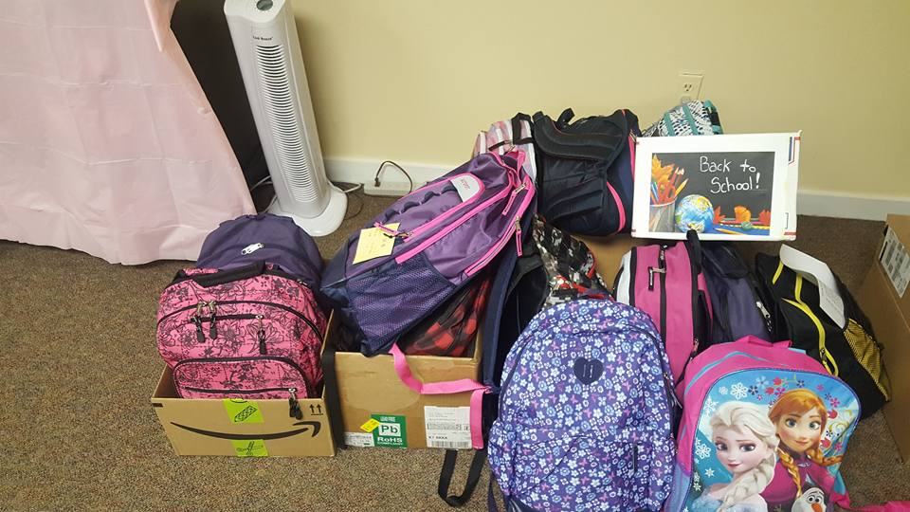
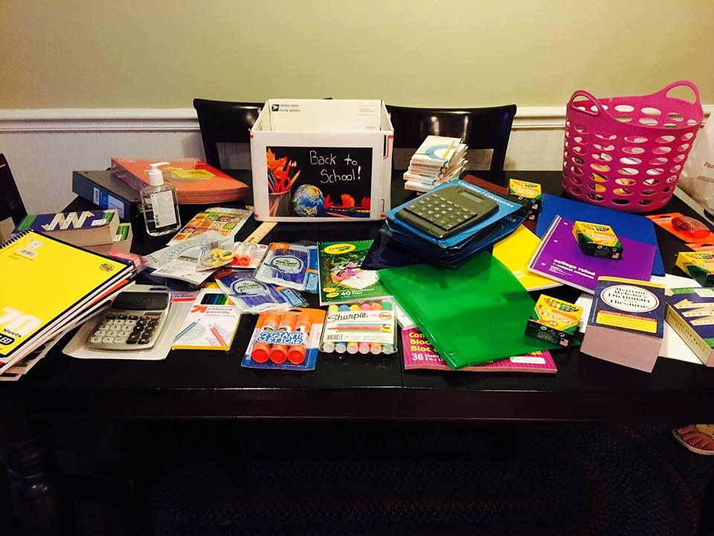
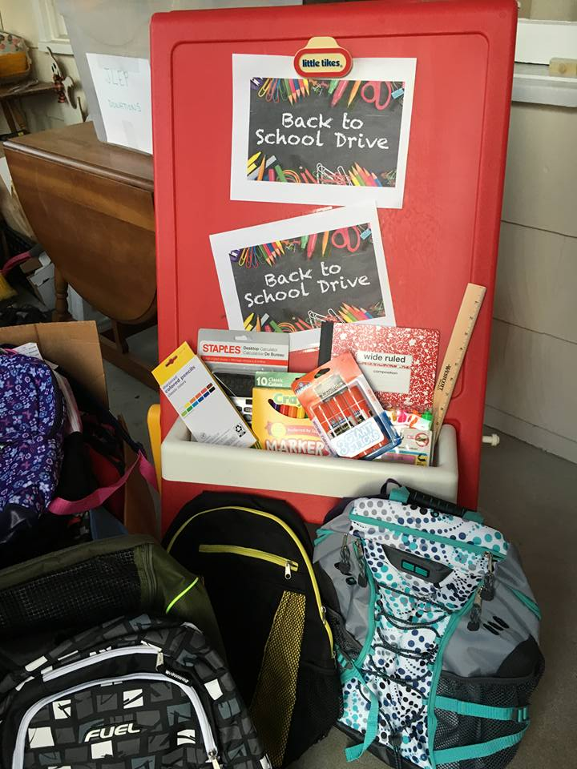
From Left to Right – President Elect Suzanne Gallagher, active members Jane Jacobs, Tyhesha Cromwell, and Jalonda Dumay, and HH Committee Chair Jen McComb.

